

LAB # 5
TASK 5 :
Trace the suplied tree by hand using minimax

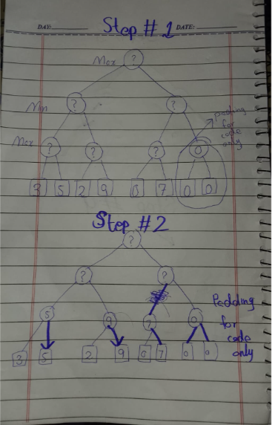
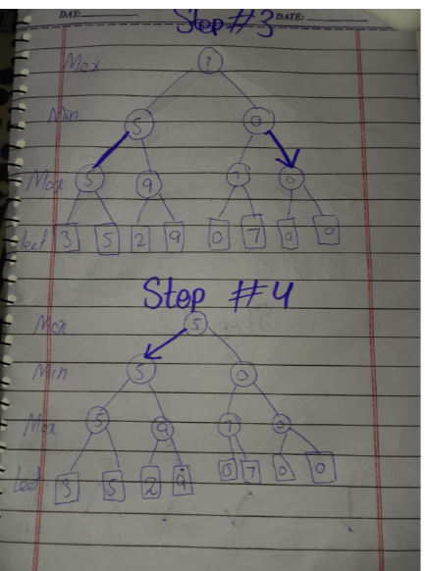
level 3 (max) : 3, 5, 2, 9, 3, 5, 2, 9
level 2 (max ): I take max of pair (3,5)gives 5 &(2,9)gave 9
level 1 (min):I take min of (5,9) which give 5 on both sides
level 0 (max ): root take yhe max of (5,5) then the final answer is 5
Task 2 & 3 output and comparision

Task 02: Add a leaf-evaluation counter to both algorithms
I added two conters leaves_mm for Minimax & leaves_ab for Alpha-Beta. Both start at zero. Are reset before every test. Each conter increase by one inside base case that is every time the function reaches a leaf & evaluates its score.

Counter in Minimax:
leaves_mm = 0
#for minimax
def minimax(curDepth, nodeIndex, maxTurn, scores, targetDepth):
global leaves_mm
if curDepth == targetDepth:
leaves_mm = leaves_mm + 1
return scores[nodeIndex]

Counter in Alpha-Beta:
leaves_ab = 0
#for alpha beta conter
def alphabeta(depth, index, maxTurn, scores, target, alpha, beta):
global leaves_ab
if depth == target:
leaves_ab = leaves_ab + 1
return scores[index]

Output for the supplied tree [3,5,2,9,3,5,2,9]:
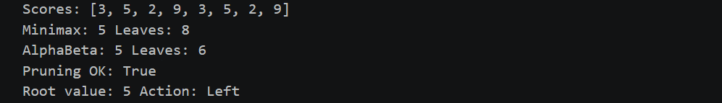
Both algorithms give a root value of 5. While Minimax looks at all eight leaf nodes Alpha-Beta checks sex. It successfully remove the leaves that have values of 2 and 9 on the side These brancheds so not affect the choice. Alpha-Beta skip them. This shows efficiency. It cuts down on work. It does this without making any mistekes. The result is accurate.
Task 03: Reorder branches and observe pruning
I rearranged the leaf nodes into four different setups: normal best-case worst-case and all-equal. After testing both algorethm on every setup the root value remained completely unchanged throughout. The only difference was performaance: the order of the leaves determined how many nodes Alpha-beta had to evaluate before finding the solutions.
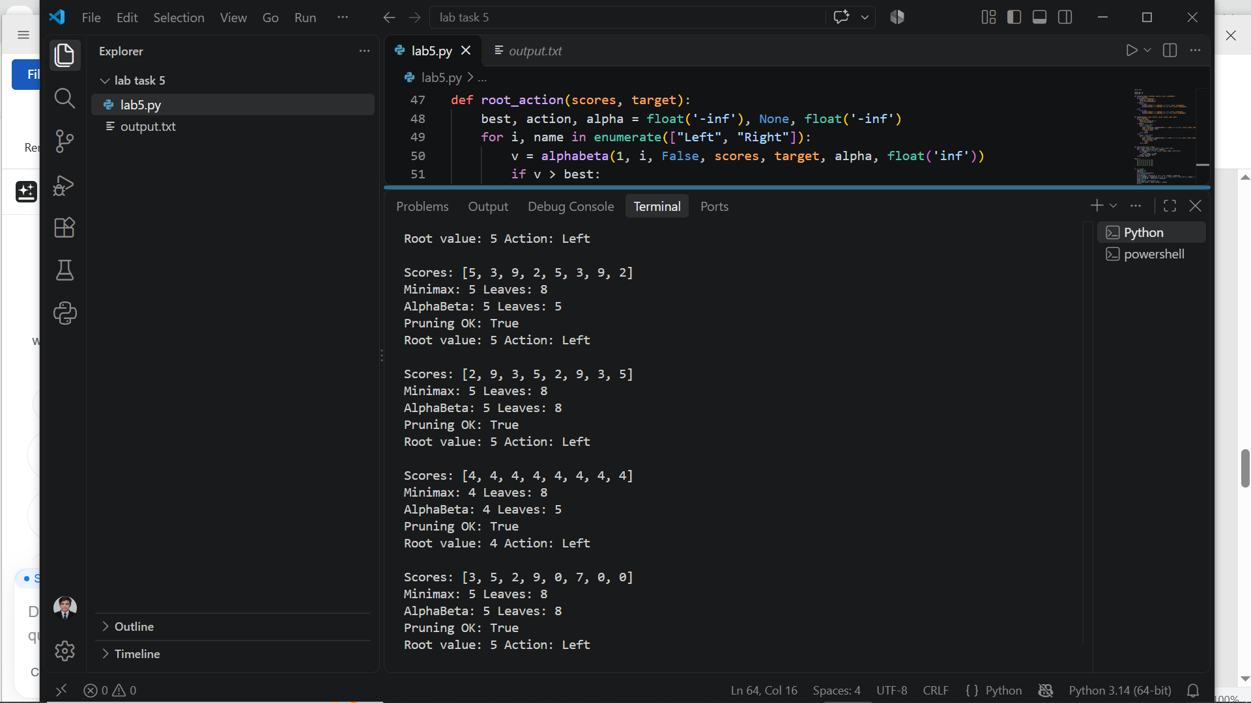

Level | Scores List | Root Values | Minimax Leaves | Alpha-Beta Leaves
Normal | [3,5,2,9,3,5,2,9] | 5 | 8 | 6
Best Order | [5,3,9,2,5,3,9,2] | 5 | 8 | 5
Worst Order | [2,9,3,5,2,9,3,5] | 5 | 8 | 8
Equal (Edge Case) | [4,4,4,4,4,4,4,4] | 4 | 8 | 5
Padded (Limit Test) | [3,5,2,9,0,7,0,0] | 5 | 8 | 8

TASK # 3 explanation edge cases and & limitation

Explanation
Both Minimax and Alpha-Beta produced the same root value in every test showing that pruning does not change the final decision of the search. Minimax always evaluates all eight leaf nodes. Alpha-Beta’s speed depends a lot on leaf ordering. With the ordering Alpha-Beta checks only six leaves. When the first MAX node on the branch returns a value of 5 beta is set to 5. Because the left branch already set alpha to 5 the condition α ≥ β is satisfied causing Alpha-Beta to prune and skip the remaining leaves with values 2 and 9.
Reordering Effects
In the ** Order** [5 3 9 2 5 3 9 2] the best values come first in each MAX pair, which allows Alpha-Beta to prune right away. Alpha-Beta looks at 5 leaves—the fewest possible for this tree. In contrast in the Worst Order** [2, 9 3 5 2 9 3 5] the bad values come first wiping out any chance to prune. Because of this Alpha-Beta has to examine all 8 leaves. It behaves just like Minimax. No matter the order the root value stays 5 showing that the order of nodes changes how much work is done but not the final answer.
Edge Case Analysis
When every leaf node has the value, such, as all 4s we see an interesting edge case. Because the pruning rule is set to α ≥ β ties cause Alpha-Beta to cut a branch away. After the MAX pair finishes, alpha and beta both become 4 so Alpha-Beta skips the rest of the branch. As a result Alpha-Beta checks 5 leaf nodes, which is the best possible case while Minimax keeps checking all 8 leaves even though it is not needed.
Limitations & Constraints
This implementation only works with trees that have a number of leaves that is a power of 2. If the tree is unbalanced or has a number of leaves that's not a power of 2 we must pad the leaf list with placeholder values for example zero-padding [3, 5 2 9 0 7]. Adding padding can change the true root value. Also the savings we see here come from a 8-leaf tree but Alpha-Beta’s advantage grows a lot as the tree gets deeper and has more branches.

Root Action Function
I added a root_action function to run Alpha-Beta pruning from the root node. The root_action function identifies the move for MAX either Left or Right and also returns the root value. For all five test cases the root_action function chose Left each time and produced root values 5, 5 5 4 and 5. When both branches give the value, such as the first test where both sides give 5 the Alpha-Beta pruning algorithm picks Left because it only changes the best move when it finds a value strictly greater than the current best.

Reflection
1. Key Takeaways
I gained an understanding of how the Minimax algorithm calculates the best decision paths. I also learned how Alpha-Beta pruning improves efficiency by removing branches that are not relevant while still keeping accuracy.
2. Real-World AI Application
I can use these principles in game-playing AI engines for games such as Chess, Checkers or Tic-Tac-Toe. By skipping subtrees Alpha-Beta pruning lets the agent evaluate possible moves much faster.
3.. Observations
I was surprised by how much leaf ordering can affect the amount of work needed. By reordering the input array the number of leaf evaluations fell from 8, to 5. The final root decision stayed the same at 5.
4. Future Enhancements
In projects I plan to test these algorithms on larger game trees that are dynamic and have deeper search levels. I will also vary the branching factors to see how performance scales.
5.. Transparent AI Practice
To guarantee reproducibility I documented the tree structures, the leaf values the number of nodes evaluated and the exact points where pruning happened. This allows peer reviewers to replicate the tests and confirm the selected moves.

problem phases:
Yeh task start mein thora hard tha. Is liye maine AI aur YouTube tutorials ke zariye pehle Minimax aur Alpha-Beta ko achhi tarah samjha. Concept clear hone ke baad agle do din mein code mukammal kiya, doston se discuss karke cheezon ko behtar banaya, aur project GitHub par push kar diya. Grading se pehle milne wale waqt ka faida uthate hue maine class se ek raat pehle code mein kuch mazeed changes aur refinements bhi kar deen.

